D-ISA106 State - Based Control (SBC)

CTRL Designer LLC

2024.10.10

Table of contents

# 1. Introduction

CTRL Designer LLC (**CDL**) is a leading provider of **SBC** state-based control (procedural control) based on ISA106 solutions to the process industries.

Its software portfolio and work processes help process control engineers develop an overall process control design and convert it automatically to the selected control system code. These solutions allow users to make smarter decisions to improve safety, reliability, efficiency, and sustainability.

The following are discussed as an introduction to CDL interpretation of ISA106.

| Chapter | description |
| --- | --- |
| A | ISA106 Overview |
| B | ISA106 Models |
| C | ISA106 Automation Styles |
| D | ISA106 State-Based Control (SBC) |
| E | ISA106 Sequenced-Based Control (SqBC) |
| F | ISA106 Work Process Overview |
| G | CDL Work Process Overview |
| H | CDL tools to develop URS |
| I | CDL tools to develop FRS |
| J | CDL tools to develop DCS-DDS |

In this section, **D-ISA106 State - Based Control (SBC)** is reviewed

## 1.1 No Header Found

Please review the following slide: 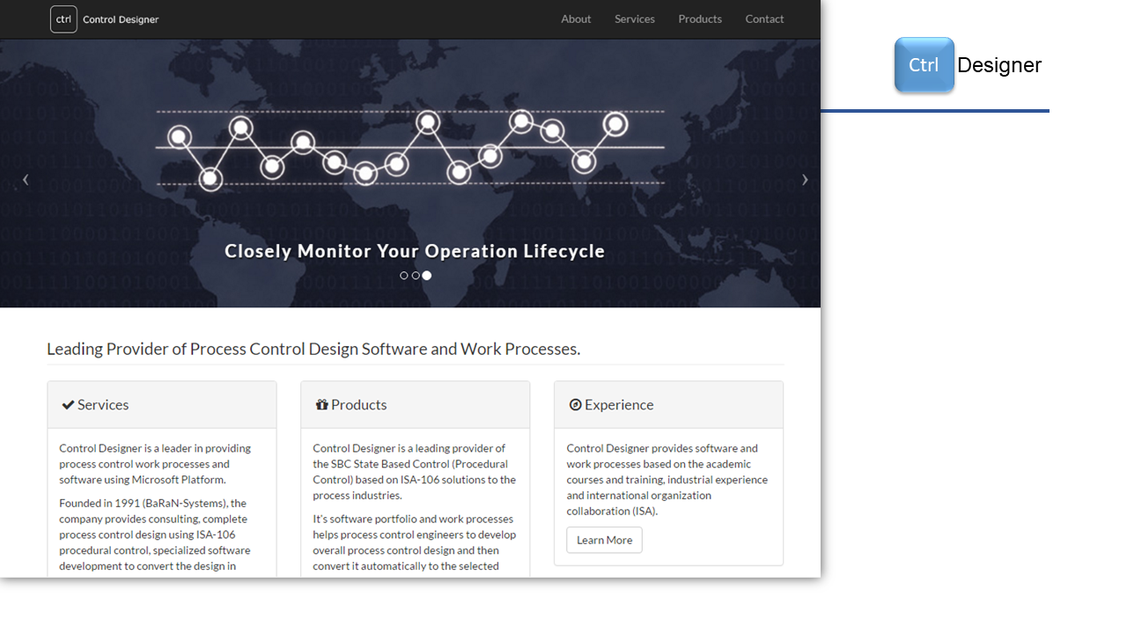 Copyright @ 2024 CTRL Designer LLC - CtrlDesigner.Com

## 1.2 CTRL Designer LLC (CDL)

Please review the following slide: 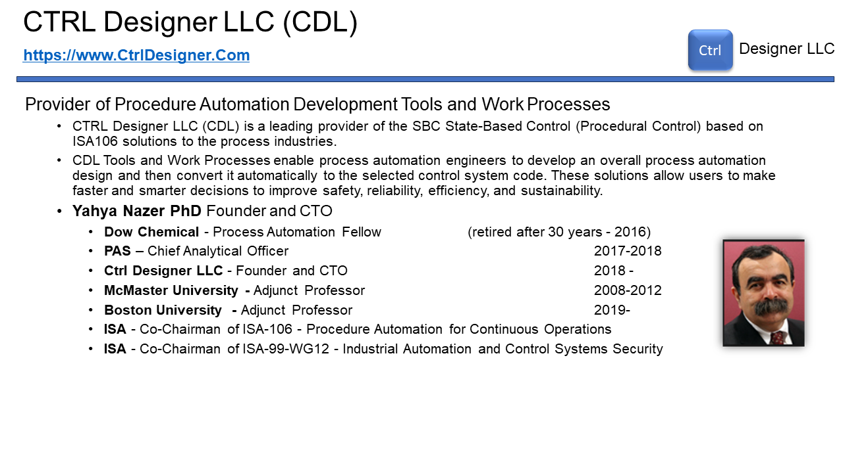 Copyright @ 2024 CTRL Designer LLC - CtrlDesigner.Com

## 1.3 Presentation Agenda

Please review the following slide: 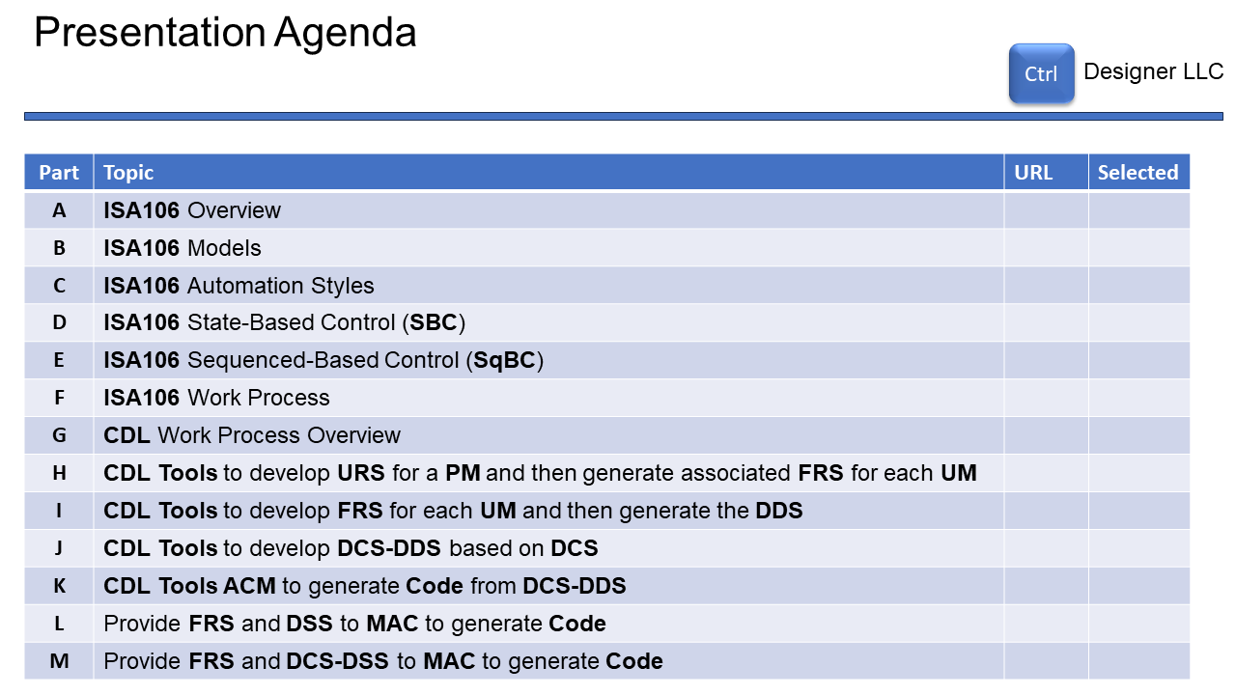 Copyright @ 2024 CTRL Designer LLC - CtrlDesigner.Com

## 1.4 Presentation Agenda

Please review the following slide: 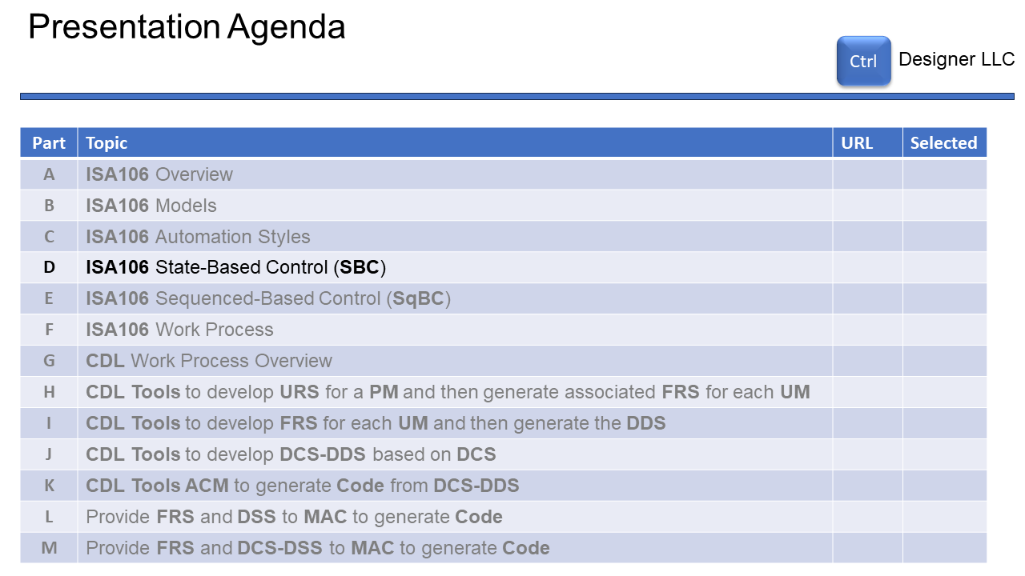 Copyright @ 2024 CTRL Designer LLC - CtrlDesigner.Com

## 1.5 CDL State-Based Control (SBC)

Please review the following slide: 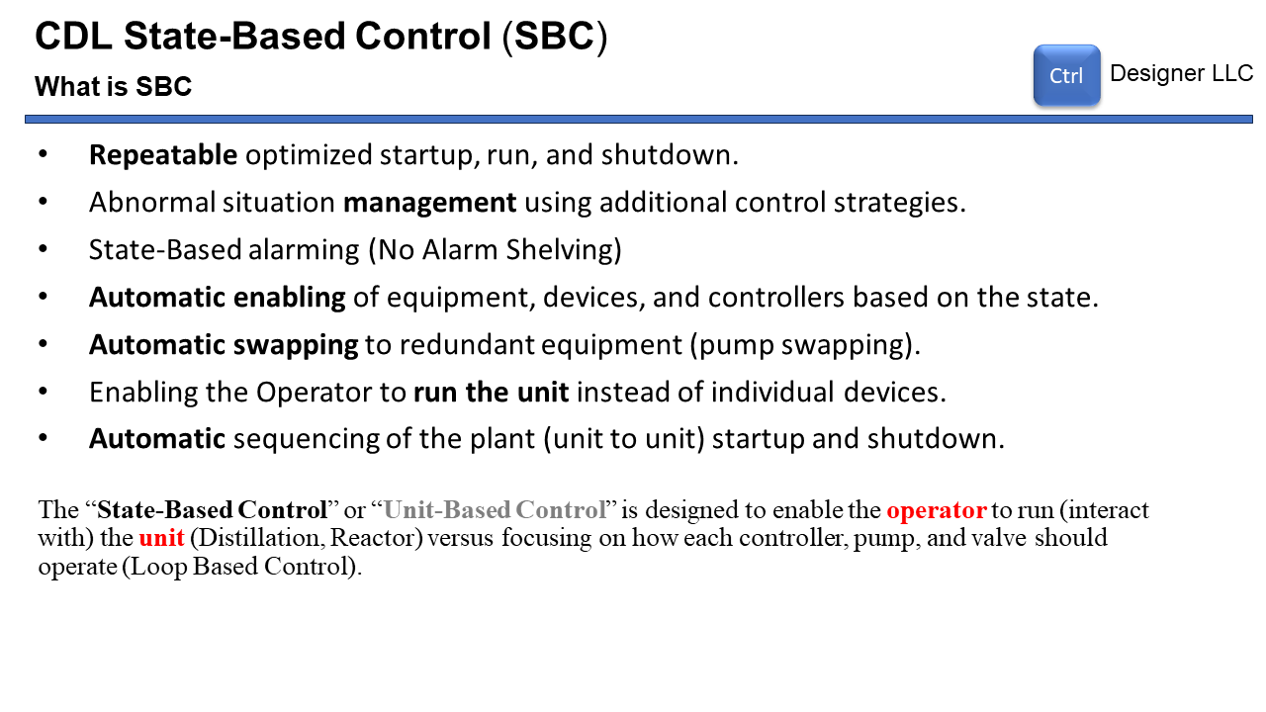 Copyright @ 2024 CTRL Designer LLC - CtrlDesigner.Com

## 1.6 CDL State-Based Control (SBC)

Please review the following slide: 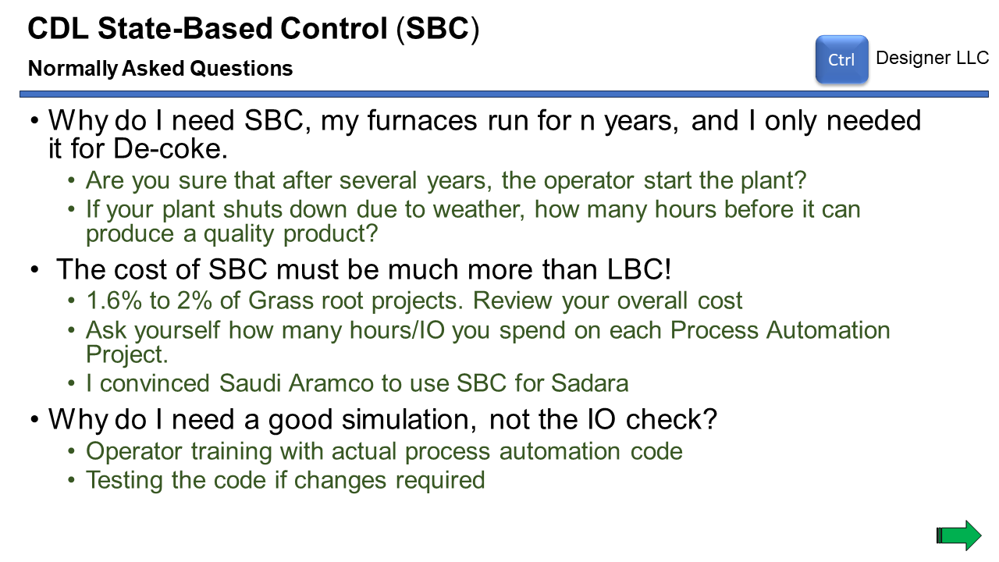 Copyright @ 2024 CTRL Designer LLC - CtrlDesigner.Com

## 1.7 CDL State-Based Control (SBC)

Please review the following slide: 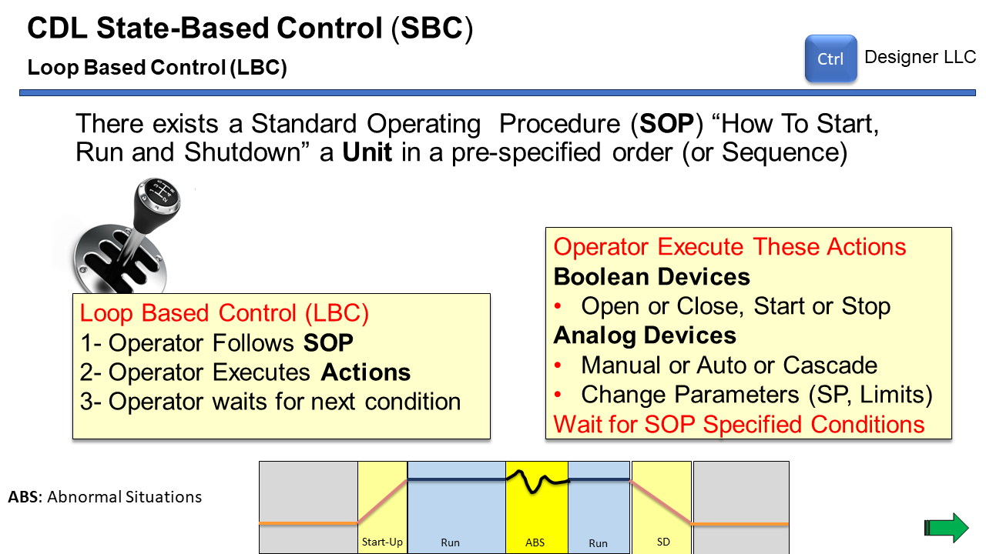 Copyright @ 2024 CTRL Designer LLC - CtrlDesigner.Com

## 1.8 CDL State-Based Control (SBC)

Please review the following slide: 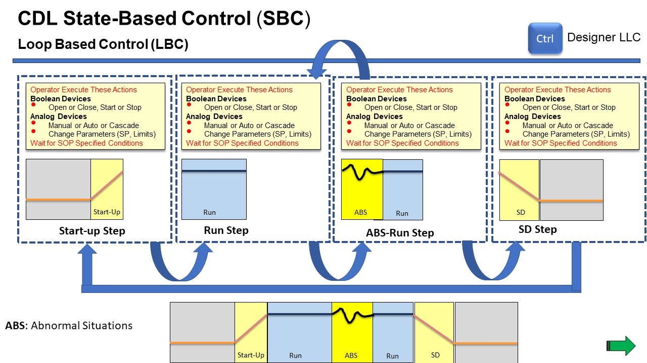 Copyright @ 2024 CTRL Designer LLC - CtrlDesigner.Com

## 1.9 CDL State-Based Control (SBC)

Please review the following slide: 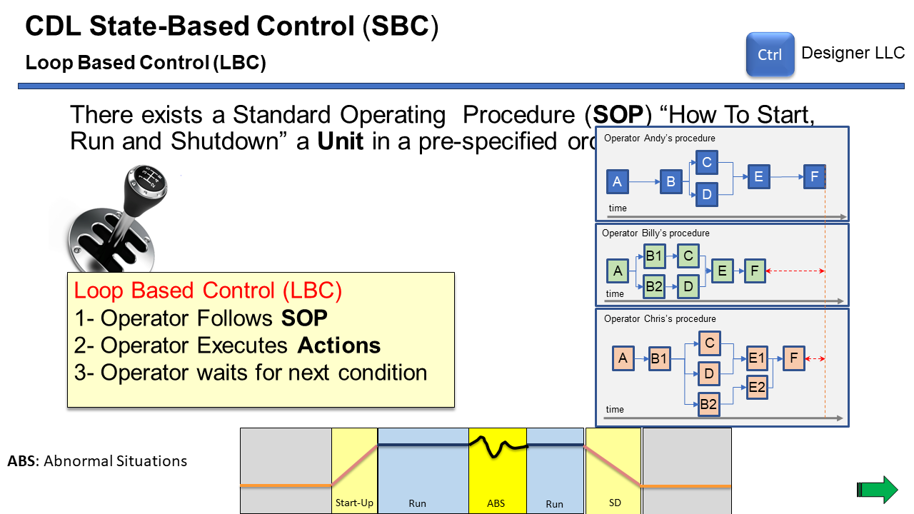 Copyright @ 2024 CTRL Designer LLC - CtrlDesigner.Com

## 1.10 CDL State-Based Control (SBC)

Please review the following slide: 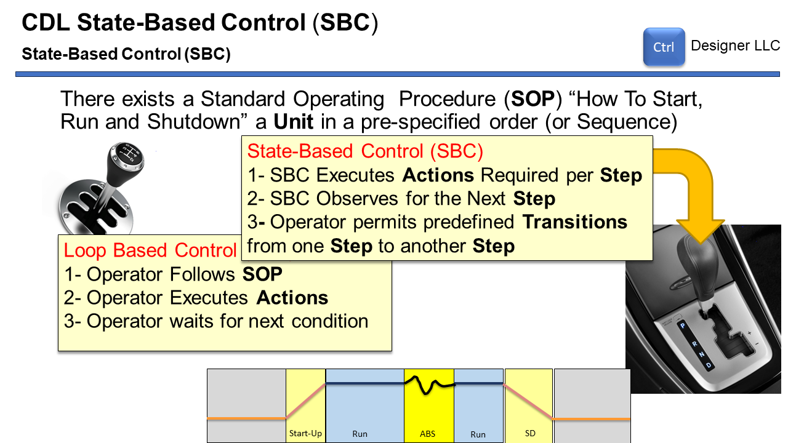 Copyright @ 2024 CTRL Designer LLC - CtrlDesigner.Com

## 1.11 CDL State-Based Control (SBC)

Please review the following slide: 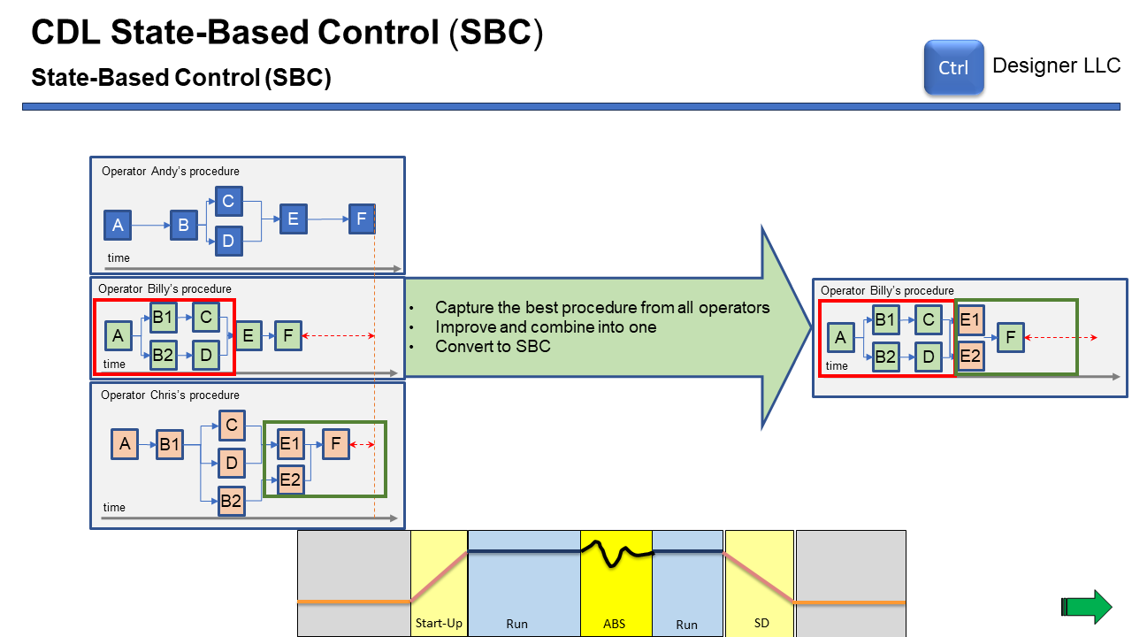 Copyright @ 2024 CTRL Designer LLC - CtrlDesigner.Com

## 1.12 CDL State-Based Control (SBC)

Please review the following slide: 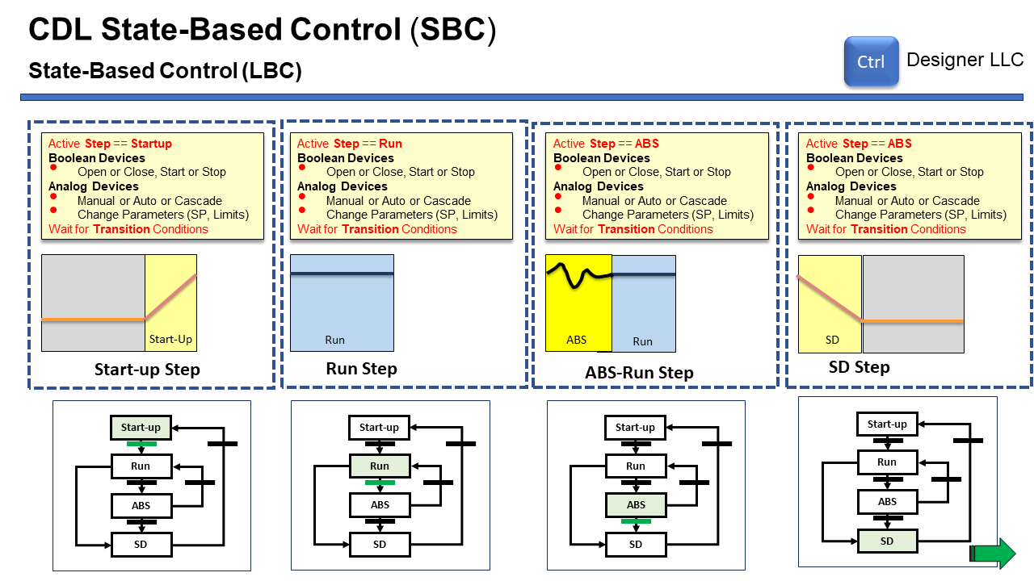 Copyright @ 2024 CTRL Designer LLC - CtrlDesigner.Com

## 1.13 ISA106 Standard

Please review the following slide: 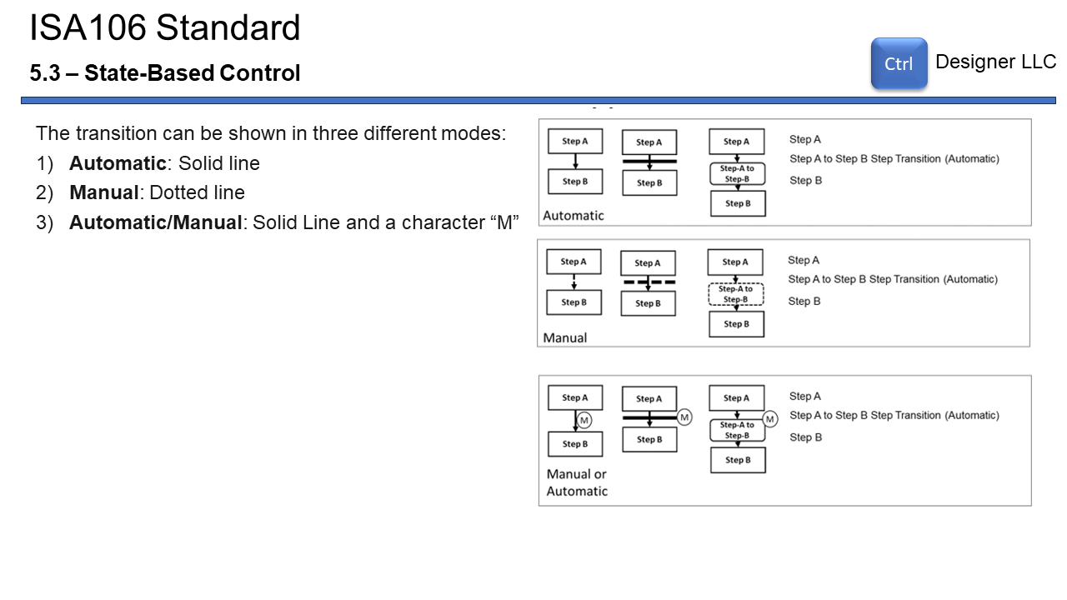 Copyright @ 2024 CTRL Designer LLC - CtrlDesigner.Com

## 1.14 ISA106 Standard - State-Based Control

Please review the following slide: 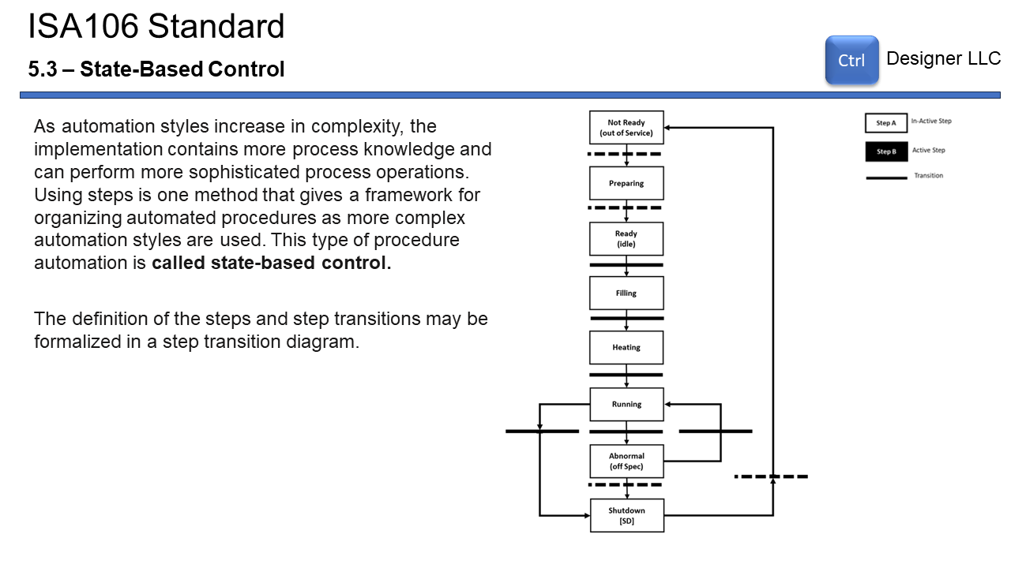 Copyright @ 2024 CTRL Designer LLC - CtrlDesigner.Com

## 1.15 ISA106 Standard - State-Based Control

Please review the following slide: 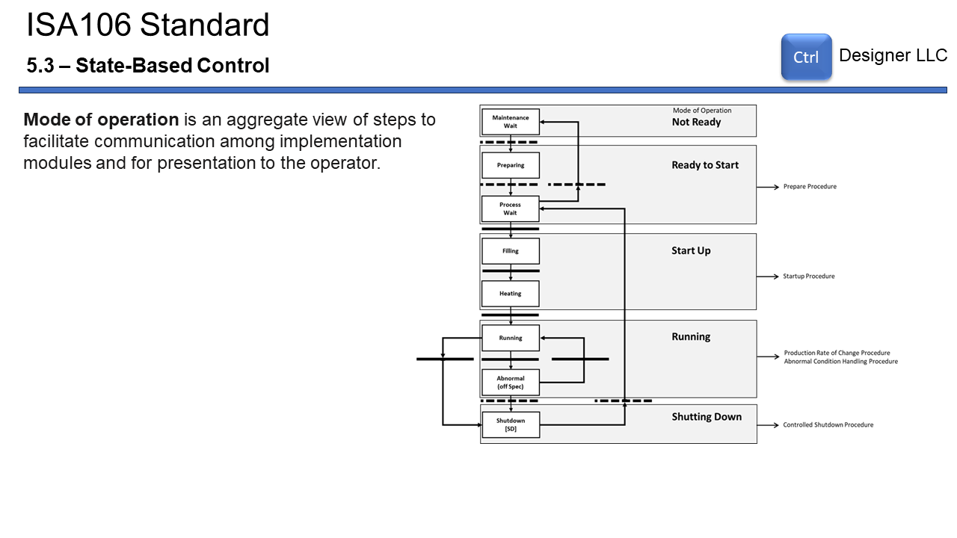 Copyright @ 2024 CTRL Designer LLC - CtrlDesigner.Com

## 1.16 ISA106 Standard - State-Based Control

Please review the following slide: 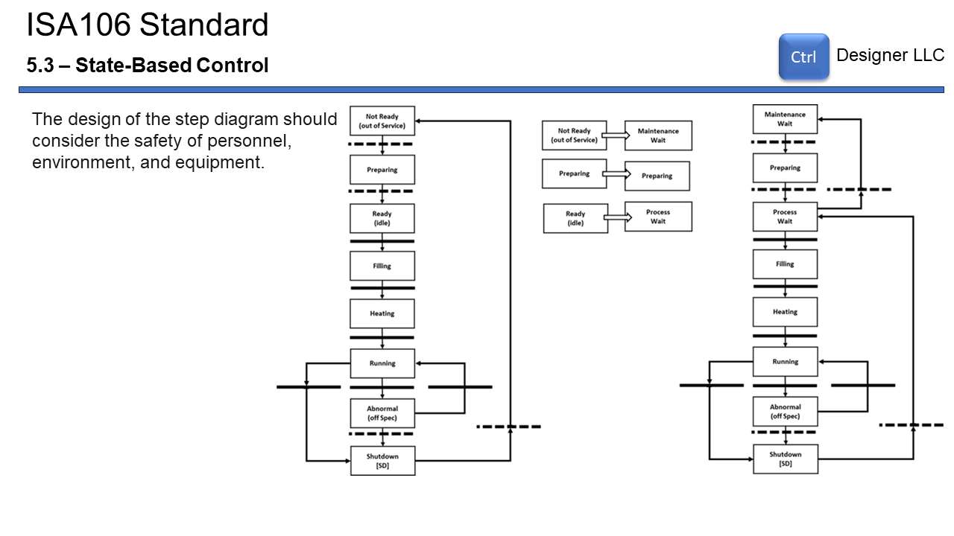 Copyright @ 2024 CTRL Designer LLC - CtrlDesigner.Com

## 1.17 ISA106 Standard - State-Based Control

Please review the following slide: 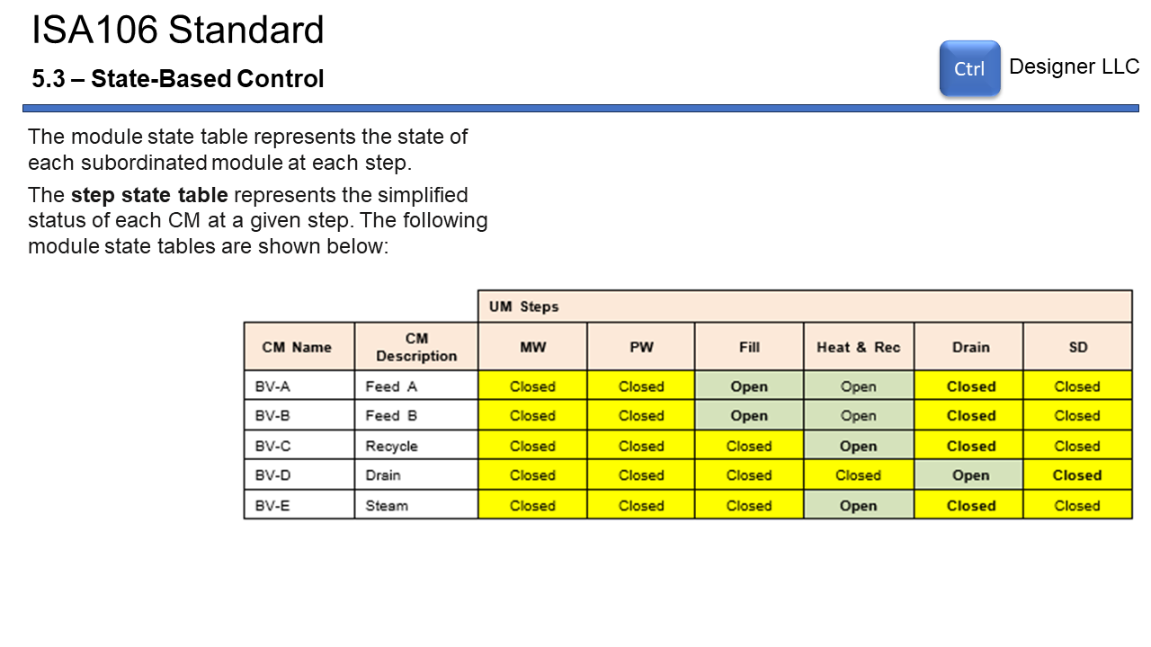 Copyright @ 2024 CTRL Designer LLC - CtrlDesigner.Com

## 1.18 ISA106 Standard - State-Based Control

Please review the following slide: 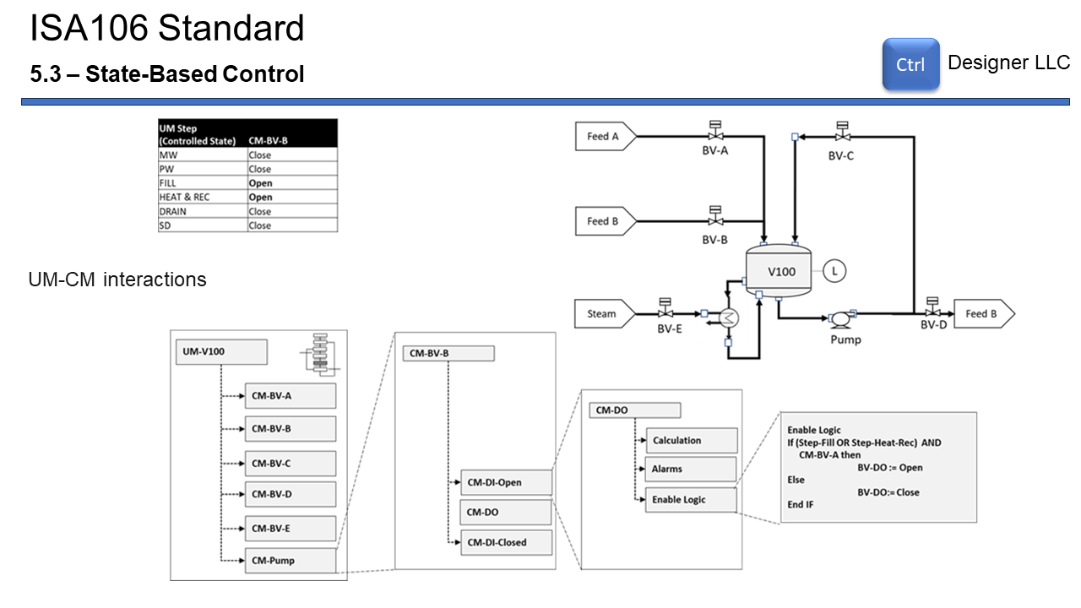 Copyright @ 2024 CTRL Designer LLC - CtrlDesigner.Com

## 1.19 ISA106 Standard - State-Based Control

Please review the following slide: 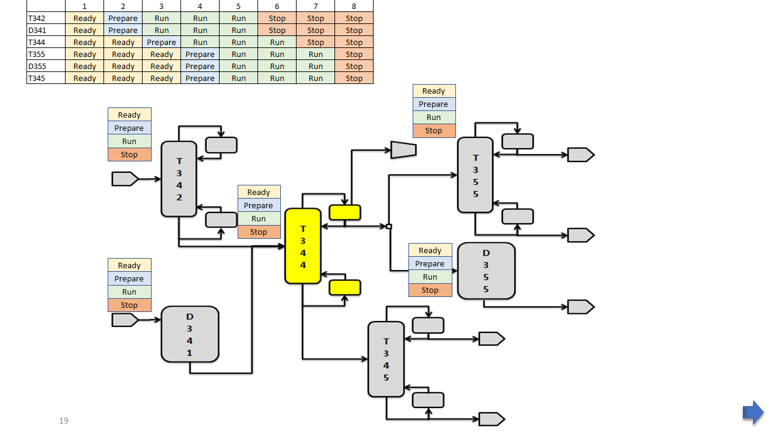 Copyright @ 2024 CTRL Designer LLC - CtrlDesigner.Com

## 1.20 Overview of a Chemical Site (Plants)

Please review the following slide: 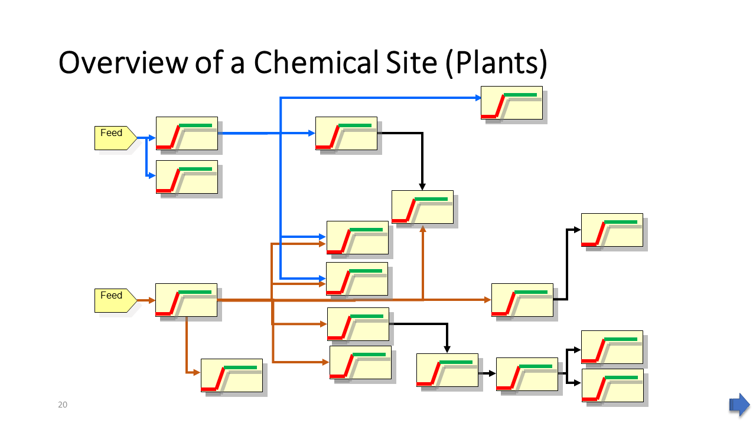 Copyright @ 2024 CTRL Designer LLC - CtrlDesigner.Com

## 1.21 Unit Example

Please review the following slide: 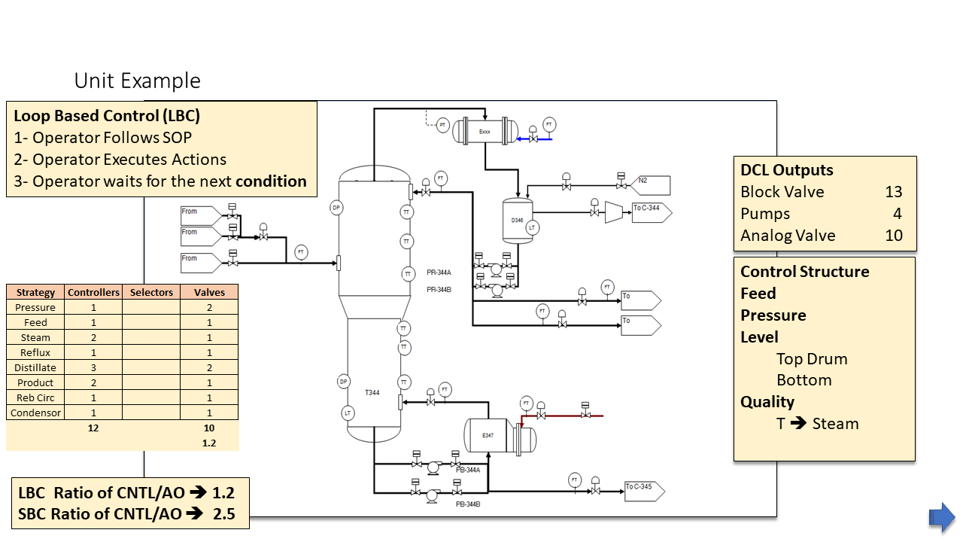 Copyright @ 2024 CTRL Designer LLC - CtrlDesigner.Com

## 1.22 MW - Maintenance Wait

Please review the following slide: 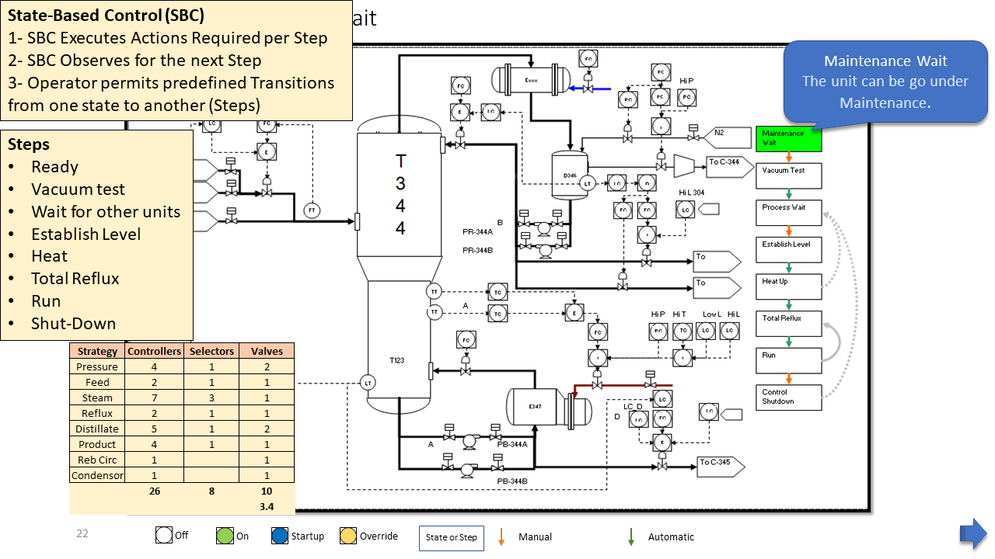 Copyright @ 2024 CTRL Designer LLC - CtrlDesigner.Com

## 1.23 Test Vacuum

Please review the following slide: 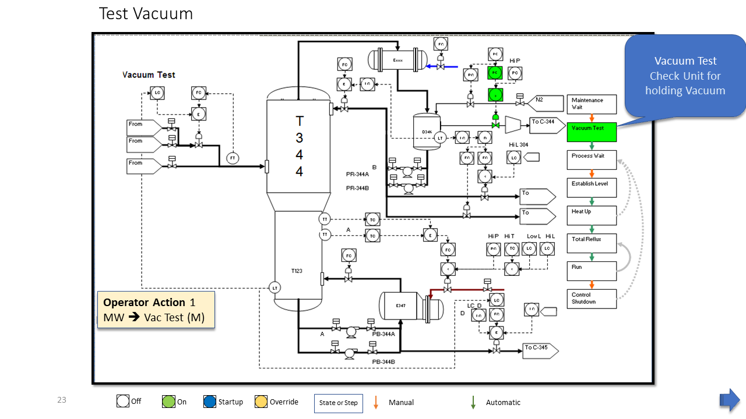 Copyright @ 2024 CTRL Designer LLC - CtrlDesigner.Com

## 1.24 Process Wait

Please review the following slide: 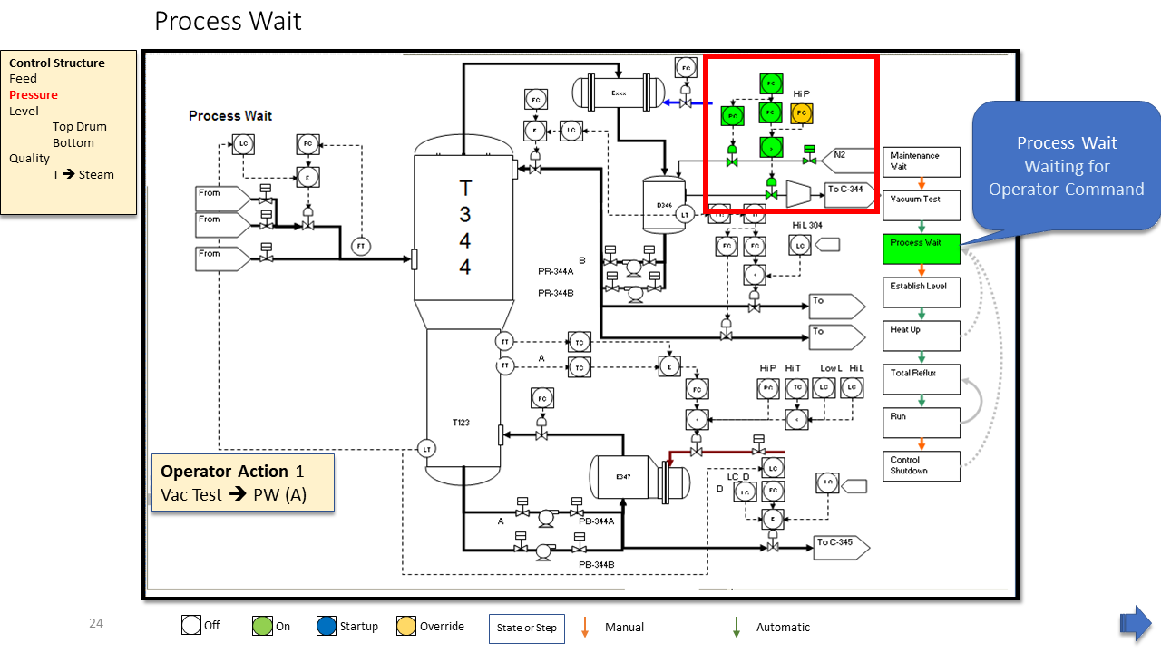 Copyright @ 2024 CTRL Designer LLC - CtrlDesigner.Com

## 1.25 Establish Level

Please review the following slide: 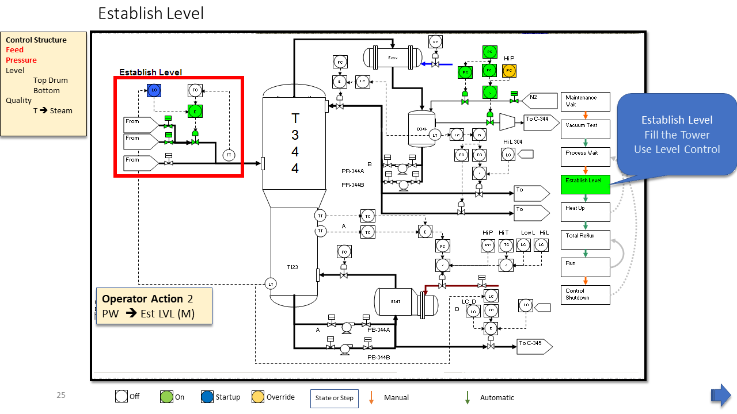 Copyright @ 2024 CTRL Designer LLC - CtrlDesigner.Com

## 1.26 Heat-Up

Please review the following slide: 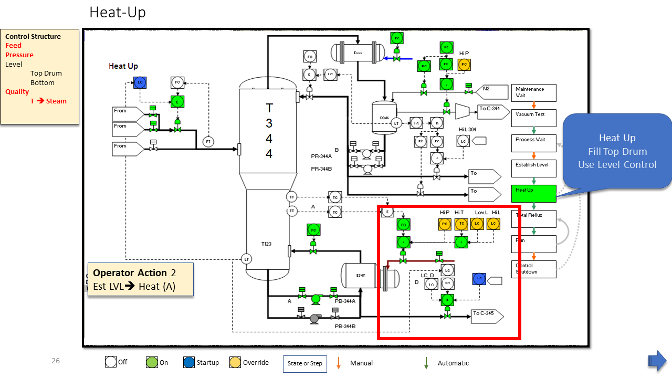 Copyright @ 2024 CTRL Designer LLC - CtrlDesigner.Com

## 1.27 Total Reflux

Please review the following slide: 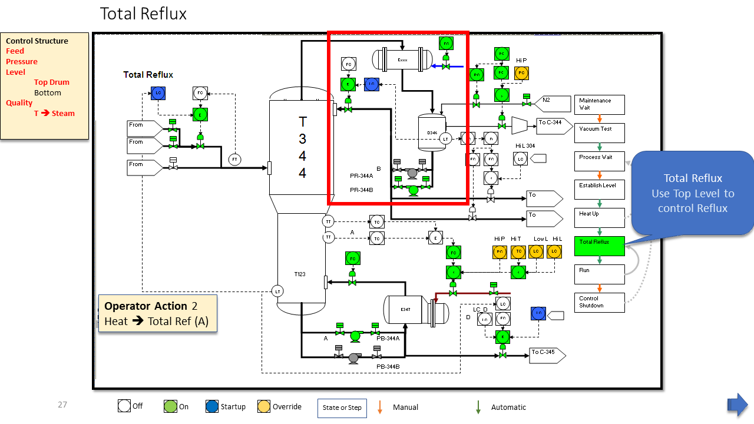 Copyright @ 2024 CTRL Designer LLC - CtrlDesigner.Com

## 1.28 Run

Please review the following slide: 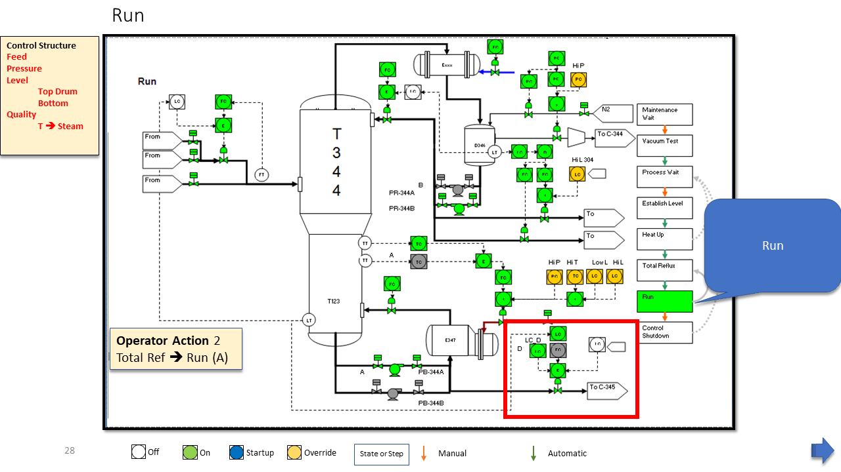 Copyright @ 2024 CTRL Designer LLC - CtrlDesigner.Com

## 1.29 Controlled Shutdown

Please review the following slide: 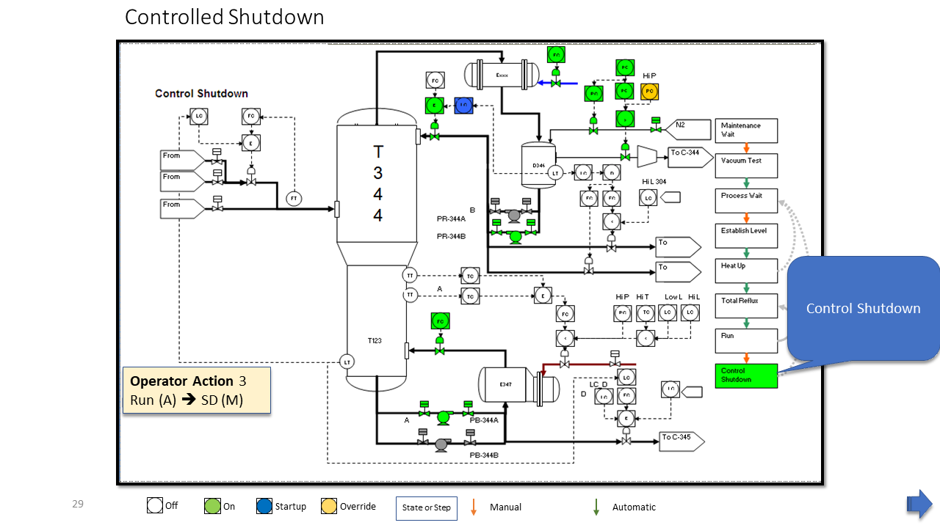 Copyright @ 2024 CTRL Designer LLC - CtrlDesigner.Com

## 1.30 Overall

Please review the following slide: 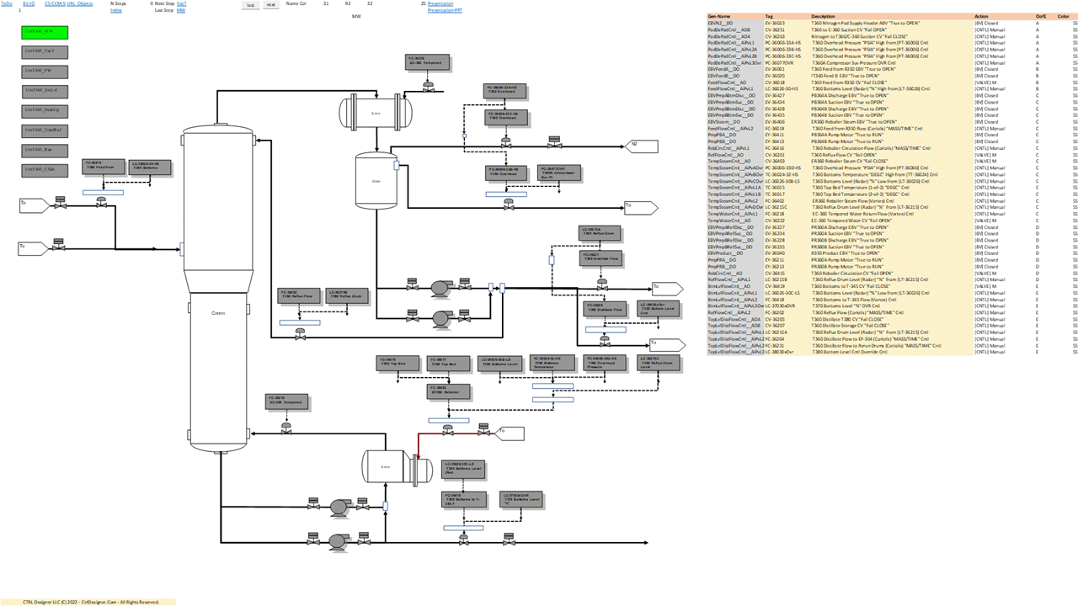 Copyright @ 2024 CTRL Designer LLC - CtrlDesigner.Com

## 1.31 Question and Answers

Please review the following slide: 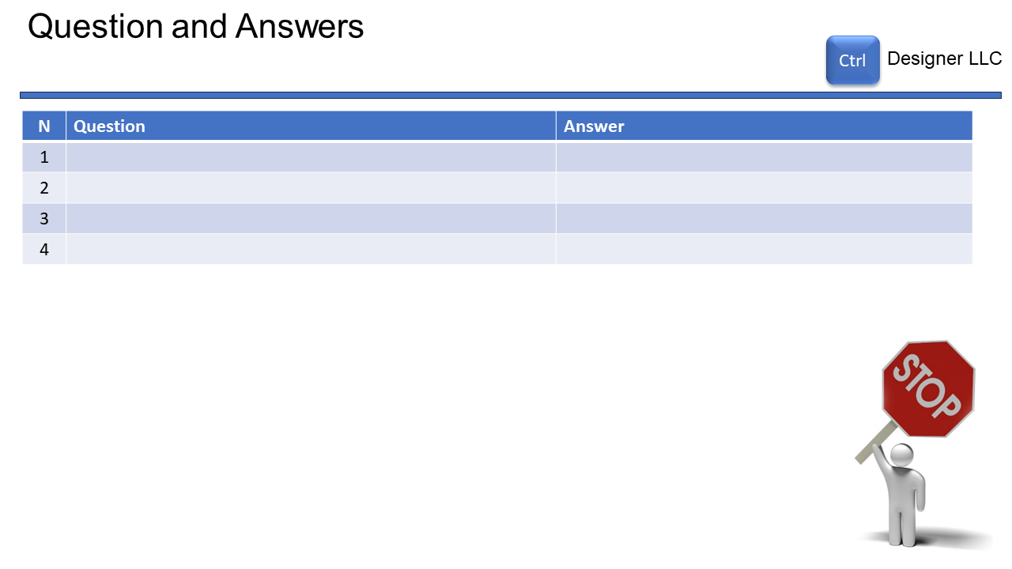 Copyright @ 2024 CTRL Designer LLC - CtrlDesigner.Com